Postprocesamiento
Torredemer
2026-05-19
library(readr)
## Warning: package 'readr' was built under R version 4.2.3
DB_ea_sports24_afterprocessing <- read.csv("C:/Users/Paco/Documents/TFM/bases_de_datos/DB_ea_sports24_afterprocessing.csv", sep=";")
fifa_after <- DB_ea_sports24_afterprocessing
# Variables numéricas
#top league
hist(fifa_after$top_league)
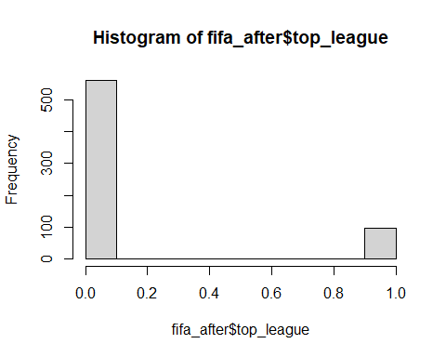
summary(fifa_after$top_league)
## Min. 1st Qu. Median Mean 3rd Qu. Max.
## 0.0000 0.0000 0.0000 0.1459 0.0000 1.0000
#overall
hist(fifa_after$overall)
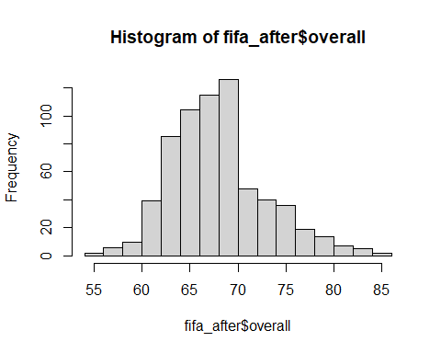
summary(fifa_after$overall)
## Min. 1st Qu. Median Mean 3rd Qu. Max.
## 55.0 65.0 68.0 68.4 71.0 85.0
#attack
hist(fifa_after$attack)
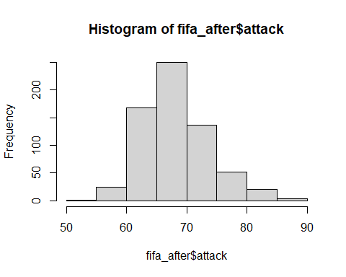
summary(fifa_after$attack)
## Min. 1st Qu. Median Mean 3rd Qu. Max.
## 54.00 65.00 68.00 68.77 72.00 90.00
#midfield
hist(fifa_after$midfield)
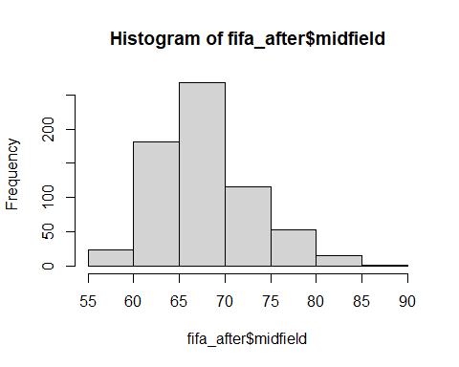
summary(fifa_after$midfield)
## Min. 1st Qu. Median Mean 3rd Qu. Max.
## 55.00 65.00 68.00 68.44 71.00 86.00
#defence
hist(fifa_after$defence)
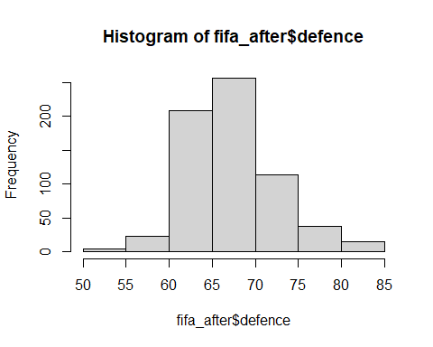
summary(fifa_after$defence)
## Min. 1st Qu. Median Mean 3rd Qu. Max.
## 52.00 64.00 67.00 67.79 70.75 84.00
#fifa defensive team width
hist(fifa_after$def_team_width)
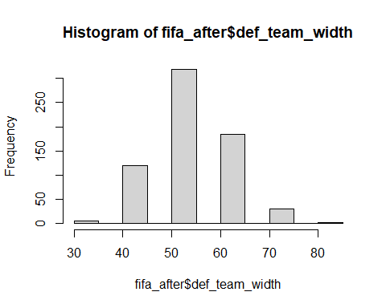
summary(fifa_after$def_team_width)
## Min. 1st Qu. Median Mean 3rd Qu. Max.
## 31.00 51.00 51.00 52.81 61.00 81.00
#fifa defensive team depth
hist(fifa_after$def_team_depth)
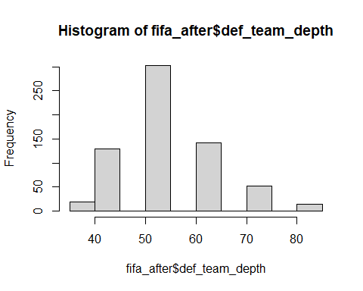
summary(fifa_after$def_team_depth)
## Min. 1st Qu. Median Mean 3rd Qu. Max.
## 37.00 51.00 51.00 53.03 61.00 81.00
#fifa offensive team width
hist(fifa_after$off_team_width)
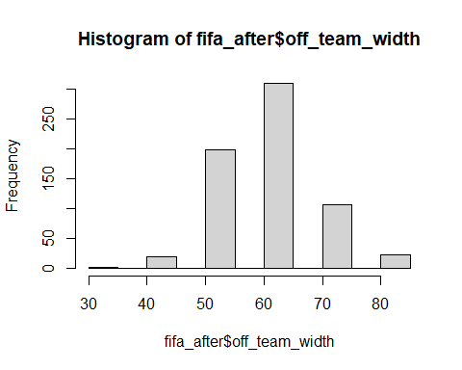
summary(fifa_after$off_team_width)
## Min. 1st Qu. Median Mean 3rd Qu. Max.
## 31.00 51.00 61.00 59.66 61.00 81.00
#fifa offensive players in box
hist(fifa_after$off_players_in_box)
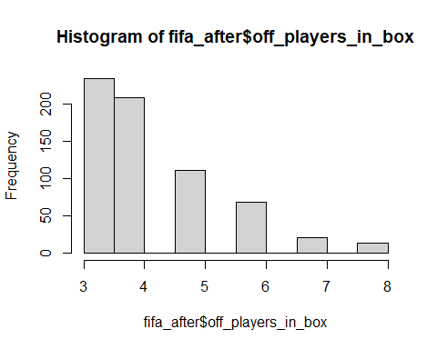
summary(fifa_after$off_players_in_box)
## Min. 1st Qu. Median Mean 3rd Qu. Max.
## 3.000 3.000 4.000 4.196 5.000 8.000
sapply(fifa_after,class)
## team_name league_name top_league nationality_name
## "character" "character" "integer" "character"
## overall attack midfield defence
## "integer" "integer" "integer" "integer"
## home_stadium def_style def_team_width def_team_depth
## "character" "character" "integer" "integer"
## off_build_up_play off_chance_creation off_team_width off_players_in_box
## "character" "character" "integer" "integer"
names(fifa_after)
## [1] "team_name" "league_name" "top_league"
## [4] "nationality_name" "overall" "attack"
## [7] "midfield" "defence" "home_stadium"
## [10] "def_style" "def_team_width" "def_team_depth"
## [13] "off_build_up_play" "off_chance_creation" "off_team_width"
## [16] "off_players_in_box"
for (i in 1:ncol(fifa_after)){
if(is.character(fifa_after[,i])){
fifa_after[,i]<-as.factor(fifa_after[,i])
}
}
#qualitative variables
#home stadium
barplot(table(fifa_after$home_stadium))
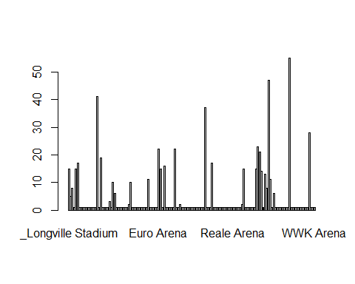
table(fifa_after$home_stadium)
##
## _Longville Stadium
## 15
## _Oktigann Park
## 5
## Aloha Park (Generic Oceania 2)
## 8
## Anfield
## 1
## Arena d'Oro
## 15
## Arena del Centenario (Estadio del Pueblo)
## 17
## BayArena
## 1
## BC Place Stadium
## 1
## Benteler-Arena
## 1
## BMO Stadium
## 1
## BORUSSIA-PARK
## 1
## Bramall Lane
## 1
## Cardiff City Stadium
## 1
## Carrow Road
## 1
## Celtic Park
## 1
## Coliseum Alfonso Pérez
## 1
## Court Lane
## 41
## Craven Cottage
## 1
## Crown Lane
## 19
## Decathlon Arena
## 1
## Deutsche Bank Park
## 1
## Dignity Health Sports Park
## 1
## Düsseldorf-Arena
## 1
## Eastpoint Arena (Football Ground)
## 3
## El Alcoraz
## 1
## El Libertador (La Bombastico)
## 10
## El Monumento (Estadio Latino)
## 6
## Elland Road
## 1
## Emirates Stadium
## 1
## Estadio Abanca-Balaídos
## 1
## Estadio Benito Villamarín
## 1
## Estadio Ciutat de València
## 1
## Estádio da Luz
## 1
## Estadio de Gran Canaria
## 1
## Estadio de la Cerámica
## 2
## Estadio de las Artes (Generic Stadium NG)
## 10
## Estadio de Mendizorroza
## 1
## Estadio de Montilivi
## 1
## Estadio de Vallecas
## 1
## Estádio do Dragão
## 1
## Estadio El Sadar
## 1
## Estadio José Zorrilla
## 1
## Estadio Libertadores de América
## 1
## Estadio Martínez Valero
## 1
## Estadio Mestalla
## 1
## Estadio Nacional (El Medio)
## 11
## Estadio Nuevo Los Cármenes
## 1
## Estadio Presidente Perón (El Cilindro)
## 1
## Estadio San Mamés
## 1
## Estadio Santiago Bernabéu
## 1
## Etihad Stadium
## 1
## Euro Arena
## 22
## Euro Park
## 15
## Europa-Park Stadion
## 1
## Forest Park Stadium (Square Ground)
## 16
## Fratton Park
## 1
## Goodison Park
## 1
## Groupama Stadium
## 1
## HDI-Arena
## 1
## Ibrox Stadium
## 1
## Ivy Lane
## 22
## Johan Cruijff ArenA
## 1
## Juventus Arena
## 1
## King Abdullah Sports City
## 2
## King Fahd International Stadium
## 1
## King Power Stadium
## 1
## Kirklees Stadium
## 1
## Kiyan Prince Foundation
## 1
## La Bombonera
## 1
## London Stadium
## 1
## Lumen Field
## 1
## Max-Morlock-Stadion
## 1
## Mercedes-Benz Arena (Stuttgart)
## 1
## Mercedes-Benz Stadium
## 1
## Millerntor-Stadion
## 1
## MKM Stadium
## 1
## Molineux Stadium
## 1
## Molton Road (Sheldon Stadium)
## 37
## Municipal de Butarque
## 1
## Municipal de Ipurua
## 1
## Nuevo Mirandilla
## 1
## O Dromo
## 17
## Old Trafford
## 1
## Olympiastadion
## 1
## Opel Arena
## 1
## Orange Vélodrome
## 1
## Parc des Princes
## 1
## Philips Stadion
## 1
## Power Horse Stadium
## 1
## PreZero Arena
## 1
## Providence Park
## 1
## Ramón Sánchez-Pizjuán
## 1
## RCDE Stadium
## 1
## Reale Arena
## 1
## Red Bull Arena (Leipzig)
## 1
## Red Bull Arena (New Jersey)
## 1
## RheinEnergieStadion
## 1
## Riverside Stadium
## 1
## San Siro
## 2
## Sanderson Park (FIFA 13 NEW generic)
## 15
## SchücoArena
## 1
## Selhurst Park
## 1
## Signal Iduna Park
## 1
## Sportpark Ronhof Thomas Sommer
## 1
## St. James' Park
## 1
## St. Mary's Stadium
## 1
## Stade Kokoto (Generic Africa 2)
## 15
## Stade Municipal
## 23
## Stadio Classico
## 21
## Stadion 23. Maj
## 14
## Stadion An der Alten Försterei
## 1
## Stadion Europa (Generic Europe 2)
## 13
## Stadion Hanguk
## 8
## Stadion Neder
## 47
## Stadion Olympik
## 11
## Stadium of Light
## 1
## Stadium Random
## 6
## Stadium_450
## 1
## Stamford Bridge
## 1
## Stoke City FC Stadium
## 1
## Swansea.com Stadium
## 1
## The Amex Stadium
## 1
## The City Ground
## 1
## The Hawthorns
## 1
## Tottenham Hotspur Stadium
## 1
## Town Park
## 55
## Turf Moor
## 1
## Udinese Arena
## 1
## Veltins-Arena
## 1
## Vicarage Road
## 1
## Villa Park
## 1
## Visit Mallorca Estadi
## 1
## Vitality Stadium
## 1
## Volksparkstadion
## 1
## Volkswagen Arena
## 1
## Vonovia Ruhrstadion
## 1
## Waldstadion (Fussballstadion)
## 28
## Wanda Metropolitano
## 1
## Wohninvest Weserstadion
## 1
## WWK Arena
## 1
pie(table(fifa_after[,9]))
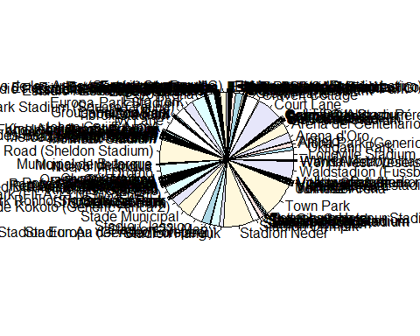
#league name
barplot(table(fifa_after$league_name))
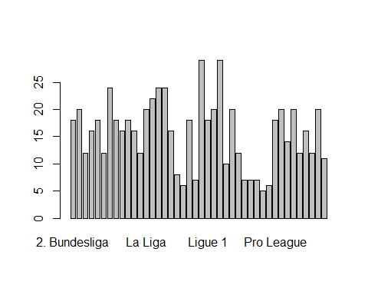
table(fifa_after$league_name)
##
## 2. Bundesliga 3. Liga A-League Allsvenskan
## 18 20 12 16
## Bundesliga Bundesliga AT Championship Ekstraklasa
## 18 12 24 18
## Eliteserien Eredivisie Jupiler Pro League K League 1
## 16 18 16 12
## La Liga La Liga 2 League One League Two
## 20 22 24 24
## Liga 1 Liga BetPlay Liga De Futbol Prof Liga Portugal
## 16 8 6 18
## Liga Pro Liga Profesional Ligue 1 Ligue 2
## 7 29 18 20
## Major League Soccer Premier Division Premier League Premiership
## 29 10 20 12
## Primera Division CL Primera Division PE Primera División PY Primera Division UY
## 7 7 7 5
## Primera Division VE Pro League Serie A Serie A BR
## 6 18 20 14
## Serie B Super League CH Super League CN Super League IN
## 20 12 16 12
## Super Lig Superliga
## 20 11
pie(table(fifa_after[,2]))
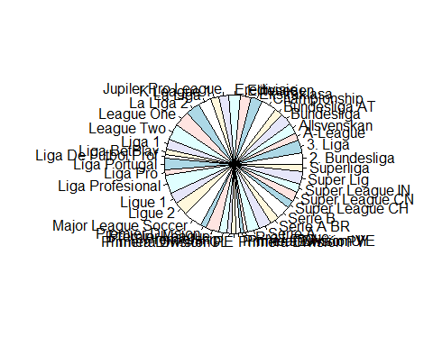
#nationality name
barplot(table(fifa_after$nationality_name))
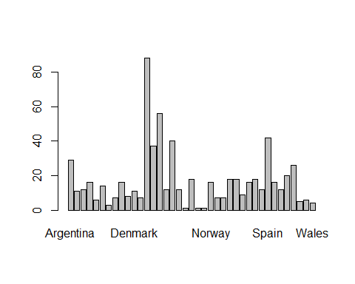
table(fifa_after$nationality_name)
##
## Argentina Australia Austria Belgium
## 29 11 12 16
## Bolivia Brazil Canada Chile
## 6 14 3 7
## China PR Colombia Denmark Ecuador
## 16 8 11 7
## England France Germany India
## 88 37 56 12
## Italy Korea Republic Monaco Netherlands
## 40 12 1 18
## New Zealand Northern Ireland Norway Paraguay
## 1 1 16 7
## Peru Poland Portugal Republic of Ireland
## 7 18 18 9
## Romania Saudi Arabia Scotland Spain
## 16 18 12 42
## Sweden Switzerland Turkey United States
## 16 12 20 26
## Uruguay Venezuela Wales
## 5 6 4
pie(table(fifa_after[,4]))
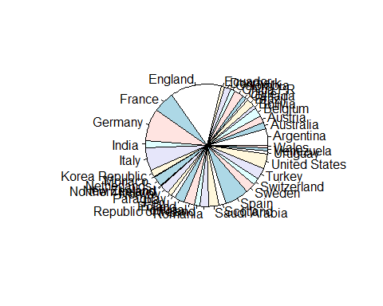
#defensive style
barplot(table(fifa_after$def_style))
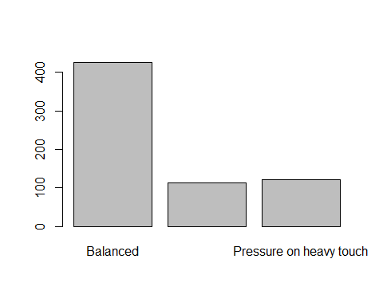
table(fifa_after$def_style)
##
## Balanced Press after possession loss
## 425 112
## Pressure on heavy touch
## 121
pie(table(fifa_after[,10]))
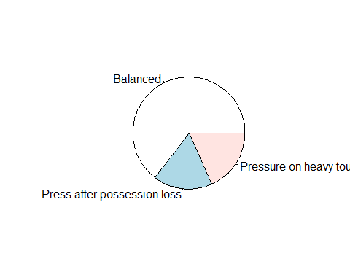
#fifa offensive build up play
barplot(table(fifa_after$off_build_up_play))
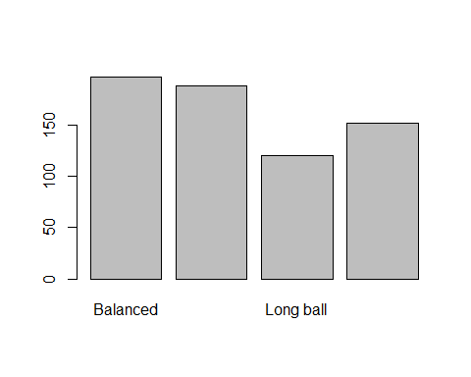
table(fifa_after$off_build_up_play)
##
## Balanced Fast build up Long ball Slow build up
## 197 189 120 152
pie(table(fifa_after[,13]))
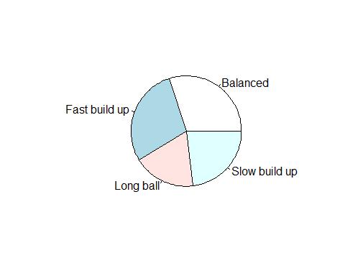
#fifa offensive chance creation
barplot(table(fifa_after$off_chance_creation))
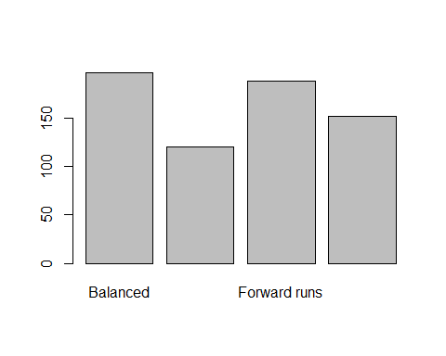
table(fifa_after$off_chance_creation)
##
## Balanced Direct passing Forward runs Possession
## 197 120 189 152
pie(table(fifa_after[,14]))
